University graduate support for www.PassivPod.co.uk at Futurebuild Excel London

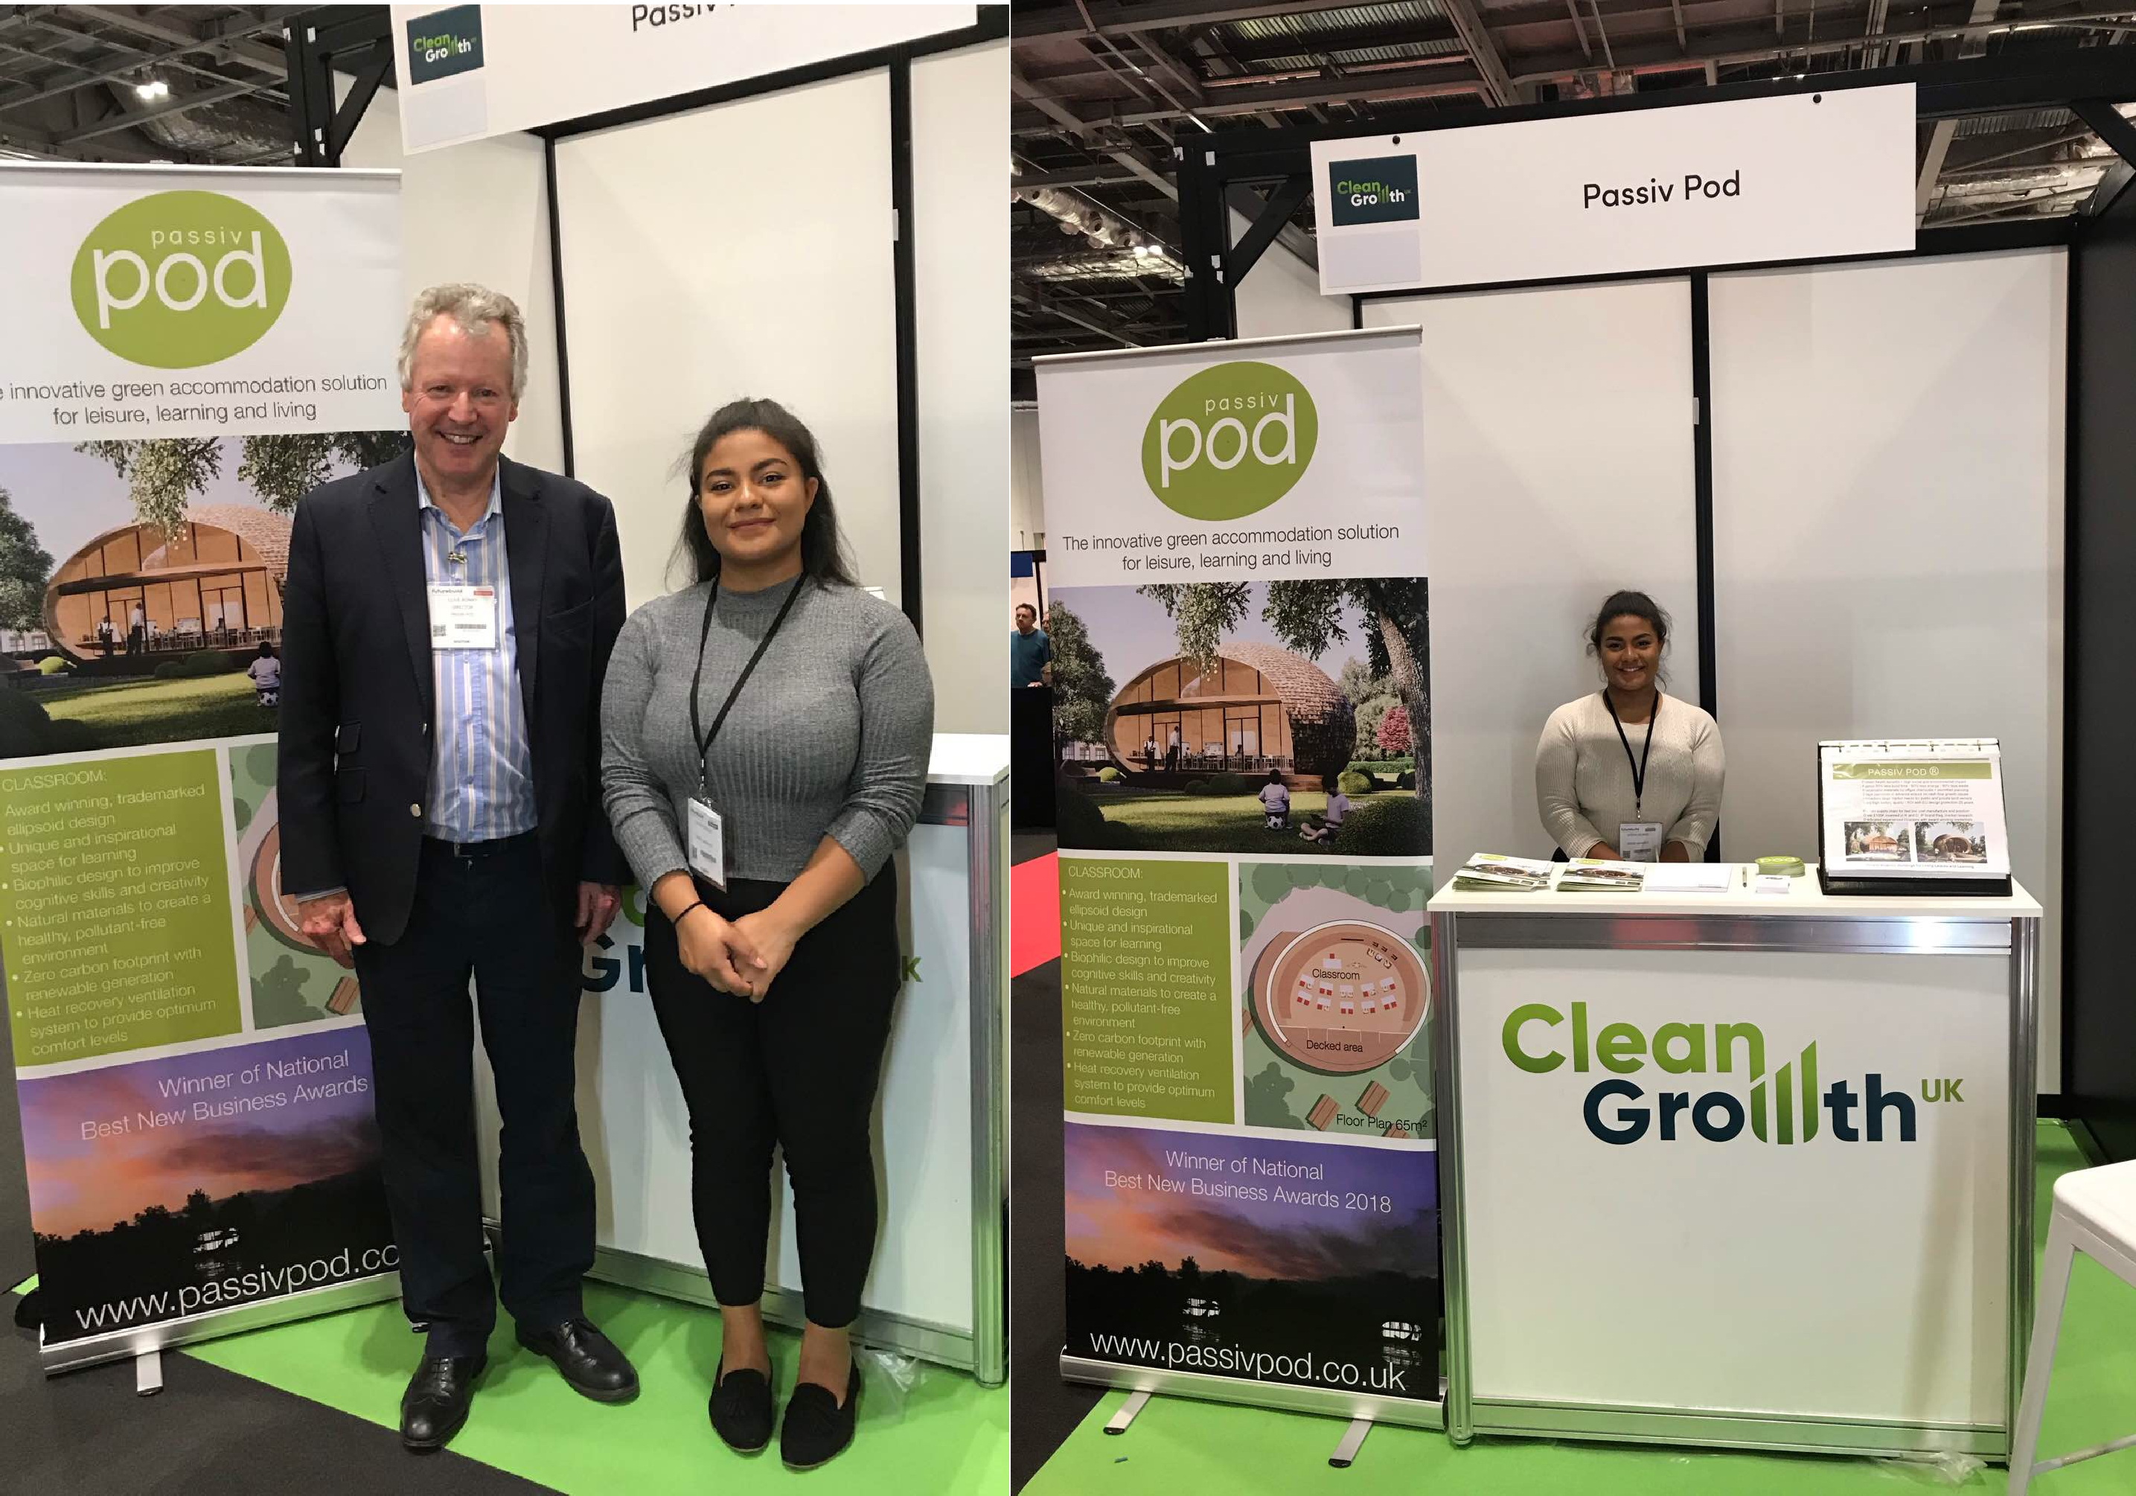

Latoya, graduating in Business and Finance, responded

What did you learn?
“I learnt that the key to success is thinking of creative innovation, the invention itself doesn’t have to be brand new just that the use for it should be unique and ideally revolutionary. When speaking to consumers it’s great to find out as much as you can about them in those early points of contact, communication is key to the success of a product, the more informed you are the easier it will be to get them to understand the benefits of the service tailored to themselves. A consumer should be left feeling more informed, and hopefully intrigued, after you have spoken to them, prompting the knowledge to be shared with others.

How will that help your career?
The advice on being creative was useful as it can be applied not only to what I am working on but also my working behaviour itself, my skills don’t have to be completely unique to what others have to offer but I need to use them a new way that makes me stand out from the crowd. The experience of work shadowing with Clive has provided valuable advice that I will take with me throughout any future ventures, and has instilled confidence in my study of Finance and Business and its ability to propel my career into working on something that is meaningful as well as potentially revolutionary.

What do you think of the product?
The PassivPod is a really revolutionary concept that can help to tackle both the housing and education sector in a fast, efficient, and cost-effective way. I look forward to a future where modular buildings follow in the footsteps of PassivPod, creating environmentally conscious designs which are fit for purpose without compromise. Every element of the biophilic design is created to maximise consumer wellbeing, from the learning benefits of teaching in a carbon neutral environment, to the abundance of natural lighting and airflow throughout the structure. It was great to be involved with PassivPod at these early stages and I am very excited to see where this venture goes and witness just how positive an impact it will have.”

Passiv Pod Director Clive Bonny adds: “Latoya applied her business and finance skills very well in promoting our products and plan to offer shares to public and private investors. Her initial enquiries included 600 eco-lodges for a Leisure Park next year and classrooms for independent schools. I recommend all employers offering graduates work experience as a really useful source of support.”

